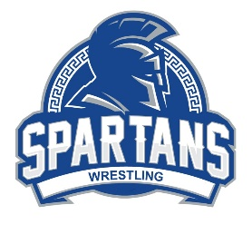 | Campbell HS Spartans Wrestling Booster Club
 | Sponsorship Information
Thank you for supporting the CHS Wrestling Team and the Spartans Wrestling Club. Your generosity is greatly appreciated and supports both programs in many ways. The Booster Club is a 501(c)(3) organization, so your donation is tax deductible.
Our sponsors will be featured on the wall of the new Gwyn-McClure gym. Your brand will be seen by thousands of athletes, parents and officials for the entire 2022-2023 school year.

Yearly Sponsorship - $300

- Each sponsor will receive (1) 24”x 18” corrugated board that displays your: company logo
(in color), phone number, and website.
- Logo posted to our website, with hotlink to your company website
- Special callout during tournaments
- Special recognition at the end of season banquets (High school and Club)

Gym location benefits:
company
logo
phone number
website
- Yearlong visibility to students, parents, and administrators
- School functions (pep rallies, Career Day, etc.)
- Multiple sports team functions (basketball, volleyball, wrestling)
- Wrestling will host 3 major tournaments, +500 attendees

Please Complete Form Below
-------------------------------------------------------------------------------------------------------------------------------
Spartans Wrestling Sponsorship Program
Sponsorship Year:
Company Name:
Contact Name:
Contact Email:
Address:
Phone:
Please make checks payable to: Campbell HS Spartans Wrestling Booster Club
Payment and donations can also be made via:
Sponsorship Portal



Email logo image (high resolution jpeg) to:
spartanswrestlingbooster.chs@gmail.com

Please return this form and payment to:
925 Powder Springs St., Smyrna, GA 30080 c/o Rudolph Armocida
Sponsorship contact:
Amy Brewton – amymb21@gmail.com

Campbell HS Spartans Wrestling Booster Club
Fundraising Goal $8,000

Sponsorship and donations support:

- Referee expenses (home meets)
- Tournament entry fees
- Team transportation (buses)
- Team meals for athletes
- Training equipment (Shot Sled - $1,500)
- Travel expenses for athletes who make the State Championship Tournament (HS)
- Travel expenses for athletes who make the National Championship Tournament (Club)

